Project Vision

# Title: Lineup Digital

# Team

|  |  |  |  |
| --- | --- | --- | --- |
| Name | Degree | Primary Role | Secondary Role |
| Andrew Kaplan | BSGD | Designer | Producer |
| Jen Sward | RTIS | Engineer | Artist |
|  |  |  |  |

# Project Duration

This is a single semester project.

# Overview

Lineup Digital is a game about demonstrating and gaining knowledge. In Lineup Digital, players compete to place their cards in a specific order based on the chosen theme and attribute. For example, Animals is the theme, and Weight is the attribute.

Lineup Digital can be played by 1 to 4 players.

Each turn players will have an opportunity to play one of their cards into the Lineup. If the player guesses the proper position in the sequence of attributes, then the card is added to the Lineup. If the player is wrong, the card is discarded, and a new card is dealt to the player active hand.

One game of Lineup Digital can take between 3 to 20 minutes. Game length is typically a reflection of the knowledge and intuition of the players and the number of players. The fewer, more knowledgeable the players the shorting the game time.

# Genre / Subject

Party game / Card game

# Target Users

Lineup Digital can be played by young and old, women and men alike. The simplicity of the rules makes the game accessible to children as young as 7.

Initially Lineup Digital will be developed for English speaking players. In the future, other languages may also be supported as well as other systems of weights and measures, e.g. Metric.

# Platform

Lineup Digital can be played on PC and Android tablets.

Users

1-4 players on single device.

# Inspiration

Lineup Digital is inspired by the physical card games Timeline, Cardline and digital versions of Trivial Pursuit.

# Core Loop

The objective of Lineup Digital is to be the first player to correctly play all their cards.

The playing deck is made up of 100 or more cards. Each card has a unique image of an object/animal/etc. from the selected theme and the title of the object. When the card is played, the selected attribute is revealed. For example, if the theme is “Animals” and the attribute is “Weight”, a card might show a Sea Lion and reveal its weight as 360 pounds.

The deck of cards is randomized, a representation of the deck is displayed on the playing surface. Each player is dealt an equal number of cards, between 3 and 6. A single card is then played from the deck onto the middle of the game board. The attribute for this card is revealed, this is the starting card.

## Multiplayer rules

The starting player is selected at random. The starting player then must play a card to the left (lessor) or right (greater) than the starting card. The card attribute is then revealed, If the player guesses correctly the card is placed in the Lineup. If the player is incorrect, the card is discarded, and a new card is dealt to the player in its place. Play continues in clockwise order, the next player must pick a card from their hand and place it in the correct position in the Lineup.

Play then continues until a player correctly places all their cards. All players are given an opportunity to tie if they have not yet played in the round and have a single card remaining. If a tie occurs even if more than two, all other players are eliminated, and the tied players are dealt a single card. Play continues until there is a single winning player.

Possible rule modification:

In order to discourage cheating in online play, as well as increase difficulty, players will be dealt their cards and not know the object of the cards. When it is their turn, one of their cards will be revealed to the player and the player will be given a set time to play their card. This will reduce the chance the player will be able to ‘Google’ the object card and discover the attribute in time to play the card.

## Single player rules

Like multiplayer rules, the player is dealt a set of cards from the deck at random. The starting Lineup card(s) is dealt from the deck, 1 to 6 cards based on player preference. There is no time limit however the player is measured by how long it takes for the player to correctly play all their cards.

Players can adjust the number of starting cards in the Lineup, the number cards dealt and if the cards are visible or revealed individually each round.

# Mock Ups

Example card art, before and after attribute reveal:

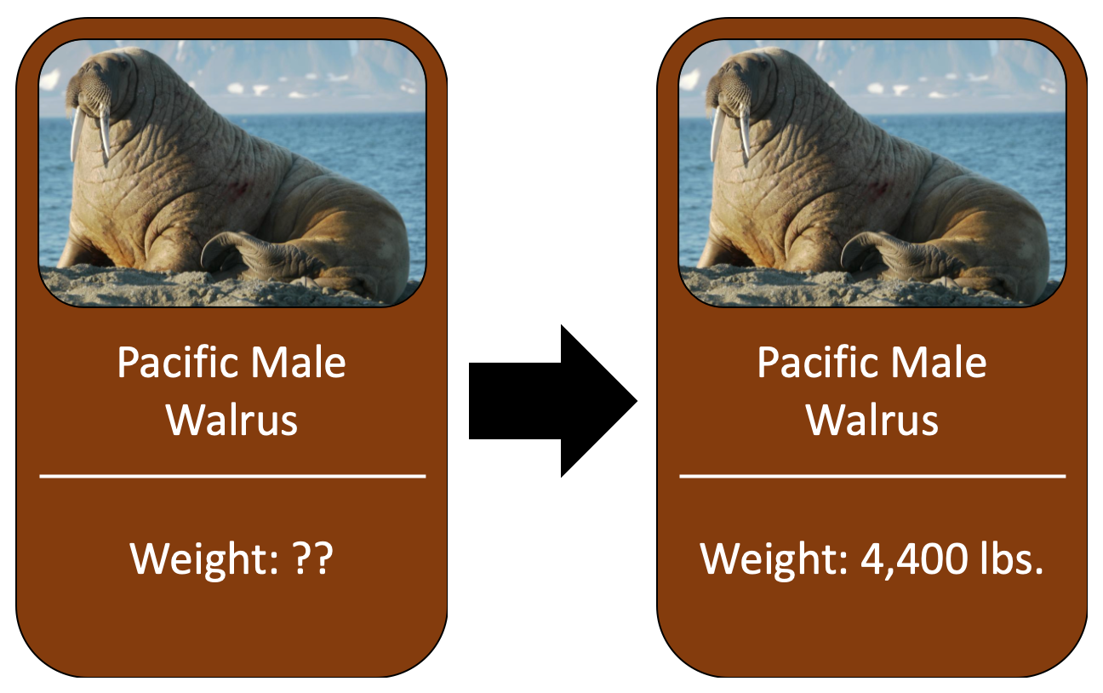

Example game board:

